Mountaineering

Oriented First Aid

Student Skill Sheets

Copyright@ Jan D. Carline February 2006

Additional WFA information added September 2017

**Step 3: Initial Rapid Check**

___ Survey the scene -- are there any environmental hazards that expose you or the patient to danger? If the hazard threatens your life, do not proceed. If the hazard threatens you or the patient, perform immediate evacuation.

___ **CHECK FOR RESPONSIVENESS:** Call or speak to the patient, introduce yourself, and ask "May l help?" If the patient does not respond to your question, tap the patient on the shoulder, and shout to see if the patient responds. If the patient can respond verbally, even with a moan, you know he or she is able to breathe.

***If the patient responds . . .***

___ Proceed to **check for severe bleeding**. Inform the patient that you are about to check for severe bleeding and will be touching his or her body.

If the patient is lightly clothed, visually scan the patient for severe bleeding.

If the patient is wearing heavy clothing, do a hands-on check for severe bleeding. Starting at the head, quickly run your hands over all surfaces of the patient's body including those next to the ground. Be sure to get underneath bulky clothing and near to skin on the patient‘s trunk and his or her limbs.

***If the patient does not respond . . .***

___ Call for assistance from another party member, and then **check for breathing**. If the Emergency Medical System is available, call for an ambulance.

___ Look, listen and feel for breathing for no more than 10 seconds [45 seconds if hypothermic].

___ If the patient is not breathing or if you can't tell because of the patient’s current position, move the patient to his or her back while supporting the head and back.

___ OPEN THE AIRWAY: When there is NO reason to suspect a neck or back injury, place the palm of one hand on the patient’s forehead, and tilt the head back until the chin is in a vertical position. Place the tips of the fingers of the other hand under the bony part of the patient's chin, and lift the jaw up and forward.

___ CHECK FOR BREATHING: With the airway held open by the head-tilt and chin-lift, turn your head so you can see the patient’s chest and abdomen and place your ear and cheek next to the patient's nose and mouth.

___ Look, listen, and feel for breathing for no more than 10 seconds.

LOOK for movement of the chest and abdomen.

LISTEN for the sound of air movement.

FEEL for air movement against the side of your cheek.

**lf the patient is breathing:** Proceed to **check for severe bleeding** (see above).

___ **If the patient is NOT breathing: Give two breaths, about 1 second long each. You should be able to see the patient’s chest rise.**

___ Check for a pulse for 5 to 10 seconds at the neck. A patient with hypothermia might need to be checked for up to 45 seconds.

___ Visually check for severe bleeding while continuing rescue breathing. ~end~

**Step 5: Check for Other Injury**

___ Interview the patient: What happened, how did it happen; when did it happen; what hurts; do you have any other problems or medical conditions; are you tired, cold, hungry; is there anyone else in your party?

___ When was last oral intake, medications taken, known allergies.

___ Observe the patient's emotional state, physical position, and ability to answer simple questions.

___ Check the pulse.

Find the pulse at the neck or wrist, count the number of beats in 15 seconds. Multiply the finding by four and record the results. Check pulse below an injury. Test capillary refill.

___ Check the rate of breathing.

Place your hand where the patient's abdomen and chest meet and count the number of movements in a minute. Record the rate and any unusual characteristics of the breathing.

___ Determine the skin’s appearance and temperature.

___ Record these and all further findings on the first aid report form.

***Begin the Head-to-Toe Examination***

**Check the head: Face, eyes, nose, mouth, ears, and scalp.**

DO NOT MOVE THE HEAD OR NECK while doing the examination.

___ Look for signs of bleeding or presence of other fluid.

___ Look for any asymmetry in the face or in facial movements.

___ Look for any sign of fracture or other deformity.

___ Look in the ears for fluid.

___ Look for blood in the eye or the presence of contact lenses. A Contact lens can be seen by opening the lids and shining a light from the outer edge across the eye. The edge of the contact lens will be seen as the light bends across it.

___ Look in the patient's mouth for wounds, loose teeth, or other injury (ask the patient to open his or her mouth).

___ Feel for any bumps, depressions, or blood. Start at the back of the head and work to the top of the head. Then check the front of the head.

___ Have the patient follow your finger with his or her eyes. Hold your finger about 18 inches above the patient’s nose. Move your finger towards the top of the patient's head and then back to the center of the face. Move your finger towards the patient's chin, then left and right ears, each time stopping at the midpoint. Note any inability to move the eye or the tendency of eye to continue moving when your finger has stopped. Both eyes should move at the same time in the same direction.

___ Check for equality of pupil size and responsiveness to light. Shade the eyes with a hand, then expose the eyes to sunlight, or flash a light in the eyes. Both pupils should contract (become smaller) promptly and evenly. Note any differences between the eyes.

**Check the neck, upper spine and upper back.**

DO NOT MOVE THE SPINE while doing the examination.

___ Look for any obvious deformity or bleeding along the neck, including abnormal position of the head with respect to the neck.

___ Feel along the spine and upper back, beginning at the top of the neck. Feel for any indication of deformity, bleeding, tenderness, or muscular spasm.

___ Look for presence of a medical alert tag.

**Step 5: Check for Other Injury** -- Continued

**Check the chest and shoulders.**

___ Look for any obvious deformity or discoloration.

___ Look for any indication of wounds or bleeding.

___ Look for any abnormal motion, such as one section of the chest collapsing while the rest expands.

___ Feel for deformity over the upper shoulders and chest. Gentle pressure should be exerted on the ribs from side to side and from front to back. Note any pain response. Place the little finger side of one hand on the sternum (middle bone of the chest) and, using the other hand, press down. Note any pain response or grating sensation.

___ Listen for any abnormal sounds on respiration or for the grating sounds of broken ribs.

**Check the abdomen and lower back.**

___ Look for any obvious deformity or discoloration.

___ Look for any indication of wounds or bleeding.

___ Feel the abdomen for any indication of muscle spasm or tender areas. Imagine the surface of the abdomen divided into four sections by a line on the long axis of the body crossed at 90 degrees by another line at the navel. Press firmly with the flat pad of your fingers in each of those sections of the abdomen, including areas below the belt line. [Spleen is below patient’s lower left quadrant.]

___ Feel along the spine and lower back for any indication of deformity, bleeding, tenderness, or muscular spasm.

**Check the pelvic area.**

___ Look for obvious deformity or discoloration.

___ Look for any indication of wounds or bleeding.

___ Look for abnormal position of the leg. The leg rolling outward may indicate injury to the hip.

___ Feel for injury of the pelvic bones. Position your hands of the sides of the pelvis, and press inward on both sides simultaneously. Without moving your hands, press on the front of the pelvis, so that pressure is exerted front to back on both sides simultaneously. Note any instability, grating, or pain.

**Check the buttocks.**

___ Look for obvious swelling or discoloration.

___ Feel for irregularities or bleeding.

**Step 5: Check for Other Injury** -- Continued

**Check upper and lower extremities.**

___ Look for obvious deformity or discoloration.

___ Look for any indication of wounds or bleeding.

___ Look for abnormal movement or position of the limbs.

___ Look for lack of symmetry between limbs.

___ Feel for tenderness, deformity.

___ Look and feel for indication of injuries to the feet and hands, and the major joints including the shoulder, elbow, hip, and knee.

___ Complete the examination of one arm before moving to the next arm, similarly for each leg.

___ Ask if the patient can wiggle his or her fingers. If there is no fracture of the arm, have the patient grip or push against your hand with his or her hand. Compare the strength of response of one hand with the other hand.

___ Ask if the patient can wiggle his or her toes. If there is no fracture of the leg, have the patient pull upward (toward the patients head) against your hand with his or her foot. Compare the strength of response on one side with that on the other. Have the patient push against your hand and compare the strength of one foot with the other.

___ Check the pulse above and below the site of any injury to determine if blood is flowing beyond the injury.

___ Check for the presence of a medical alert tag.

**Head-to-Toe Examination in an Unconscious Patient**

For an unconscious and unresponsive patient, the additional steps should be added to the Head-to-Toe examination.

___ Check the patient's level of responsiveness. Call the patient's name and note any response, either movement or noise. lf there is no response to verbal commands, check for a pain response by a pinch to the earlobe or deep pressure at the base of the thumbnail and note any reaction, either movement or noise.

___ Observe carefully for any movement during the examination that might indicate a response to a painful injury. The response might be slow, so allow time for the patient to react.

___ If contact lenses are found, remove them from the eye and store them safely.

___ Repeat the examination every 5, 15, or 60 minutes, as appropriate.

___ Talk to the patient and explain your actions as if the patient were conscious.

~end~

**SPLINTING**

**Mid Shaft Fracture of the Upper Arm:**

___ Prepare materials: A dressing of appropriate size if wound is present, padding material to place between the broken arm and the chest wall, two triangular bandages, and safety pins.

___ Explain the procedure to the patient.

___ Have the patient support the lower arm with the unaffected hand.

___ Place and secure the dressing on wound (if necessary).

___ Place padding between the broken arm and the chest wall.

___ Fold a triangular bandage so that it will make an 8-inch wide sling to support the wrist and mid-shaft of the lower arm.

___ Place one end of the triangular bandage next to the neck on the uninjured side, let the second end fall in front of the chest and between the broken arm and body.

___ Bring the second end of the triangular bandage up and around the neck, and adjust the sling so that the wrist is supported by the sling. The hand should be level with the elbow and the fingers should be visible.

___ Fasten the two ends on the side of the neck.

___ Fold the second triangular bandage to make a 5 to 6 inch wide swath.

___ Place the swathe over the lower portion of the upper arm on the injured side to secure the arm to the chest wail. Fasten the swathe in front on the unaffected side.

___ Secure the padding to the patient's clothing or the swathe with safety pins.

___ Check the pulse at the wrist, and check for capillary refill in the fingers. Adjust the splint as necessary.

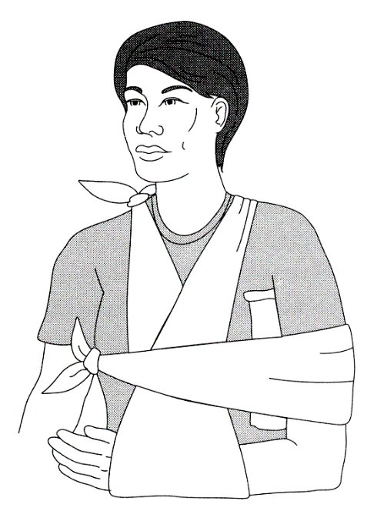

**Fracture of the Elbow:**

___ Prepare materials: A flexible aluminum-foam splint, Sam® Splint, or a ladder splint, padding for the splint, roller bandages to secure the splint, and a triangular bandage. Bend the ladder into an elongated U shape. The bottom of the U should be only as wide as the breadth of the arm.

___ Explain the procedure to the patient.

___ Do not move the arm -- splint it in the position found.

___ Position the padded splint on either side of the arm. The elbow forms one angle of a triangle; the other two angles are formed where the splint crosses the arm.

___ Secure the splint to the upper arm and forearm with soft roller bandages.

___ Fold a triangular bandage so that it will make a 3 inch wide sling to support the weight of the arm.

___ Place one end of the sling next to the neck on the uninjured side and let the second end fall in front of the chest and between the broken arm and body.

___ Bring the second end of the triangular bandage up and around the neck, and adjust the sling so that the wrist is supported by the sling. The hand should be above the elbow and the fingers should be visible.

___ Fasten the two ends on the side of the neck.

___ Check the pulse at the wrist and check for capillary refill in the fingers.

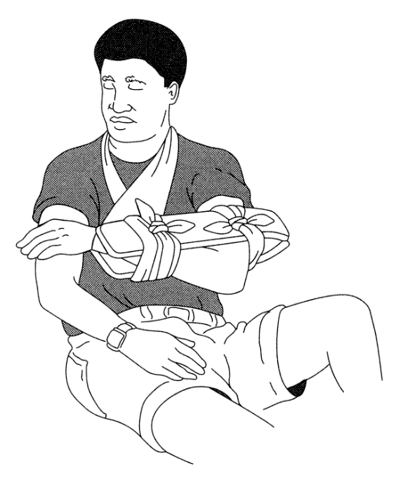

**Mid Shaft Fracture of the Lower Leg:**

**Swivel Hitch**

___ Prepare materials: Rigid splints that extend from above the knee to the ankle, padding for the splint, a dressing of appropriate size if wound is present, padding material to place between the two legs, and three cravats.

___ Explain the procedure to the patient: Remove boot, check pulse, dress wound, and apply splint.

___ Check the pulse in the foot. While one first aider supports the leg from above the ankle, a second first aider removes the boot or shoe. It is critical to have access to the toes to check circulation. A boot on the foot is necessary only if the patient intends to walk on it. A down bootie and/or several pairs of socks can be used for protection. It is possible to cut an inspection hole in the tip of the socks, and then cover the toes with another sock. In this way only one sock needs to be removed to check circulation.

___ Support the foot and leg. A first aider grasps the ankle and exerts a gentle, steady pull on the leg to stabilize the foot. Maintain the pressure until the splint has been completely tied on.

___ Place and secure dressing on wound if necessary.

___ Place three cravats underneath the broken leg, using the space under the knee or ankle for access to place the cravats. Cravats are placed at the knee, the ankle and mid thigh.

___ Slide the poles under the ties, next to the leg, and wrap each tie around the pole.

___ Add padding to fill in spaces between the rigid splint and the leg.

___ Bring both ties across the leg, bring the outer tie under and around splint and leg again.

___ Tighten as snugly as is comfortable for the patient.

___ Tie the ends together on the outside just above the splint.

___ Adjust the cravats so that the splint is snug but not tight.

___ If using an ice ax, the adz end should be at the foot with the adz at the heel and the pick at the toes. The ball of the foot may be tied to the pick to support the foot at a right angle to the leg.

___ Have the patient flex his or her toes towards the head. If the patient is unable to move his or her toes or the movement causes severe pain, then the cravats are tied too tightly.

___ Check the pulse at the ankle or check for capillary refill in the toes. Adjust cravats as needed.

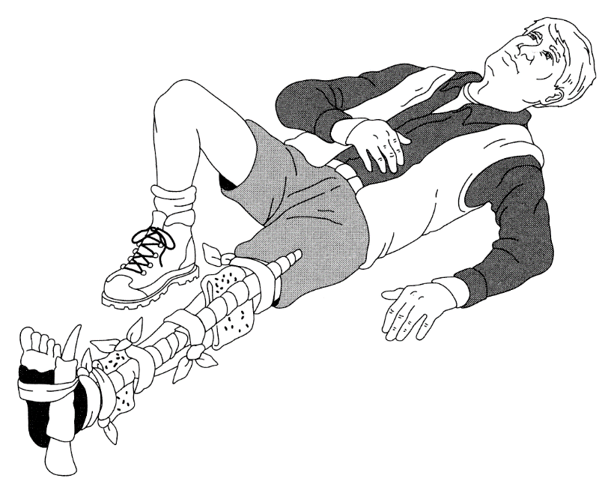

**Splinting with a Foam Pad**

**___** Assemble materials: Foam pad and cravats.

___ Explain the procedure to the patient

___ Slide the pad under the leg so that half its length is on either side.

___ Roll up the pad on either side until it snugly captures the leg.

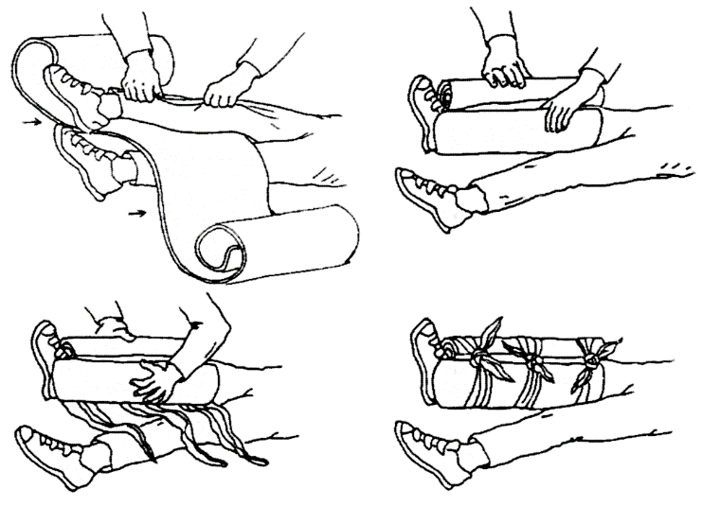___ When you secure the ties, make them as tight as the patient finds comfortable.

**Blanket Splint**

**___** Assemble materials: Blanket or bulky garment and 3 or 4 cravats.

**___** Explain the procedure to the patient.

**___** In cold weather, you might leave boot or shoe on for warmth and support but loosen laces and check regularly to make sure that swelling is not impairing circulation.

**___** Fold the blanket or bulky garment into a rectangle about 1” x 3”.

**___** If the patient is lying on the ground, slide three cravats under the ankle, slipping them through the space behind the Achilles tendon.

**___** Fold the blankets around the bottom of the foot so that it wraps the ankle and lower leg on both sides.

**___** Slip one cravat up almost to the upper edges of the blanket and tie it, pulling as tight as is comfortable for the patient.

**___** Tie the second cravat around the ankle

**___** Spread out the third cravat so that it cups the bottom corner of the blanket and heel, bring it diagonally to the instep and tighten it as much as the patient will tolerate.

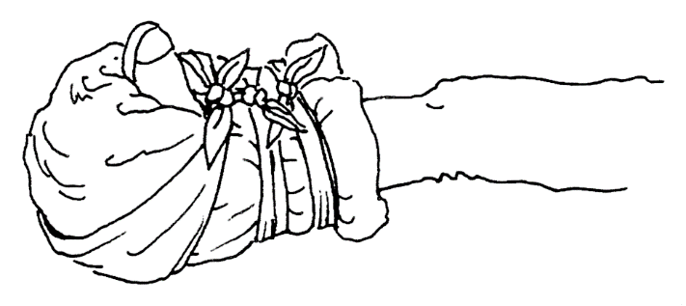**___** To provide extra support, add a figure 8 bandage; loop the center of a cravat around the booted toes, cross the tails, pass them around the splint and under the ankle, bring them back up and tie them.

**BANDAGING**

**Figure Eight Bandage on the Hand:**

For injury on palm or back of hand.

___ Assemble materials: Dressing of appropriate size for the wound and sufficient length of roller gauze bandage.

___ Explain the procedure to the patient.

___ Place the dressing on the wound.

___ Start the bandage on the on top of the dressing. Make at least two complete circular turns over the wound until the dressing is secured in place.

___ Apply the gauze diagonally across the palm side of the thumb, and around the wrist. Complete the circular turn around the wrist (top side of the hand) and then up around the palm to complete the “figure eight” design on the hand.

___ Repeat the figure-eight turns several times until the dressing is secured.

___ End the bandage with at least one full circular turn around the wrist and tie off the bandage.

**Figure Eight Bandage on Knee or Elbow:**

___ Assemble materials: Dressing of appropriate size for the wound and sufficient length of roller bandage.

___ Explain the procedure to the patient.

___ Place the dressing on the wound. Have the patient maintain dressing in place over wound.

___ Capture the dressing with the center of the bandage.

___ Wrap one tail around the limb above the joint and the other tail around the limb below the joint.

___ Bring the tails back toward each other and cross them before doing the final wrap.

___ Tie them on the outside of the joint- a knot right on the point of the elbow or knee would slip off as you flexed the joint.

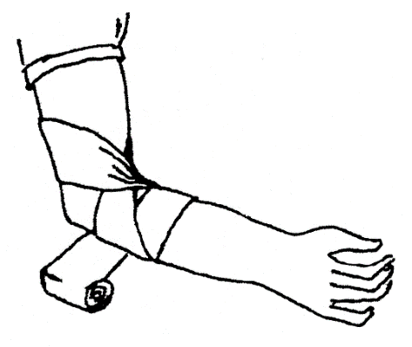

B**andaging a Leg:**

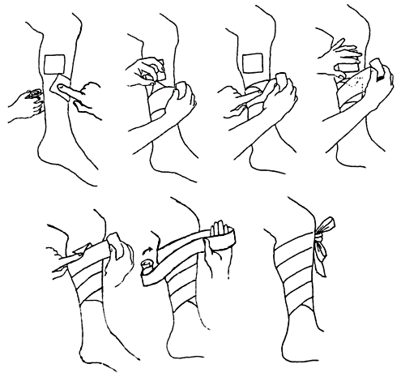___ Assemble materials: Dressing of appropriate size for the wound and sufficient length of roller bandage.

___ Unroll the bandage onto the limb, starting at the narrow end.

___ Leave on corner out, then fold it over and lock it down.

___ Overlap as you wrap, maintaining even tension.

___ Fold over and lock down the corner of the dressing.

___ Tie off the bandage above the dressing.

**Figure 8 Bandage of a Limb:**

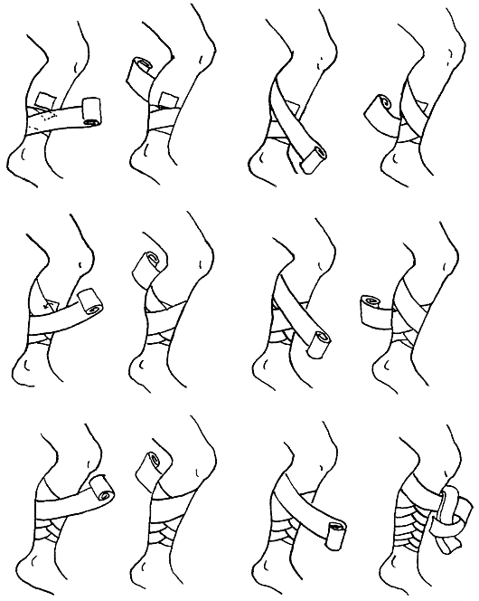___ Assemble materials: Dressing of appropriate size for the wound and sufficient length of roller bandage.

___ Begin by anchoring the bandage.

___ Wrap one full turn, angling up limb.

___ Wrap one full turn, angling down limb.

___ Continue wrapping up limb then down limb.

**Scalp and Forehead Bandage:**

___ Assemble materials: Dressing of appropriate size for the wound and a triangular bandage.

___ Explain the procedure to the patient.

___ Place the dressing on the wound. Have the patient maintain dressing in place over wound.

___ Fold a two inch hem in the base of the triangular bandage.

___ Place the bandage on the forehead so that the middle of its long edge is above the nose, the hem is to the outer side, and the point is hanging down the back of the head.

___ Bring the two ends of the bandage around the back of the head just over the ears. Cross the two ends underneath the bump on the back of the head. DO NOT TIE THE ENDS AT THE BACK OF THE HEAD.

___ Bring the ends forward to the forehead. Tie the two ends snugly over the hem on the forehead.

___ Pull the point downwards to secure the dressing against the head by pressure from the bandage while holding the bandage steady with one hand on the top of the head.

___ Pick up the point of the bandage and tuck it in where the bandage ends cross in back.

**Clothes Drag Rescue for Immediate Evacuation**

___ Explain the procedure to the patient.

___ Place the patient on his or her back.

___ Crouch behind the head of the patient, and grasp the patient's clothing close to the head.

___ Support the patient's head and neck by gathering clothing behind the neck.

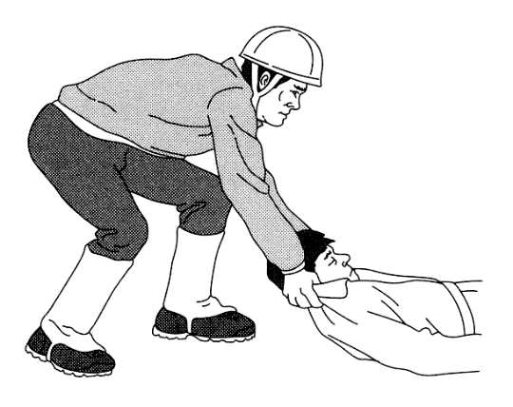___ Pull patient in the direction of the long axis of the patient's body.

**Two-Handed Seat Carry**

___ Preparation:

• Urgent first aid is completed.

• The move has been included in the plan for first aid.

• Insulation materials, tents, etc. are ready.

• Path of movement has been cleared.

• Safety of the rescuers is considered.

• Patient is conscious and able to assist, and no spinal injury is suspected.

___ Explain the procedure to the patient.

___ Rescuers assume a position behind the patient facing each other.

___ If the patient is sitting on the ground, the rescuers kneel down on the knee closest to the patient. The rescuer's arm closest to the patient is placed across the patient's back and into the patient's far arm pit. The other hand is place from the front of the patient into the closest arm pit.

___ The rescuers stand at the same time, bringing the patient to a vertical position.

___ The patient's arms are placed around the rescuers' necks. The rescuers' arms closest to the patient support the patient's back. The rescuers may interlock their arms to form a backrest.

___ The rescuers grasp each other's arms at the wrists to form a seat for the patient.

___ Crouch so that the patient may sit down on the seat.

___ Once the patient is securely seated, stand.

**Log-Roll of a Patient onto Insulation**

___ Preparation:

• Urgent first aid is completed.

• The move has been included in the plan for first aid.

• Insulation materials, sandbags, etc. are ready.

• Four rescuers are needed.

• Safety of the rescuers is considered.

___ Explain the procedure to the patient.

___ The leader of the move assumes a position directly behind the patient's head. The rescuer's hands are positioned with fingers placed supporting the back of the head and the jaw, typically with the palms of the hands covering the ears. This may be modified due to the size of the rescuer's hands compared to the patient's head or the position of the patient. The intent is to prevent motion of the patient's head relative to the rest of the body.

___ If necessary, the patient's head and neck may be moved gently and slowly to form a straight line with the spine. If there is **any** resistance to the movement, or the patient experiences **any** pain, the movement must **stop immediately**, and the head and neck be left in their present position.

___ The other rescuers assume positions on one side of the patient, kneeling on both knees. One rescuer is placed near the shoulders, the second at the hips, and a third at the knees.

___ The insulation material is placed on the far side of the patient, ready to move under the patient. The pad must be long enough to provide insulation under the head, trunk, buttocks, and upper legs of the patient. Preferably, the pad should extend from the top of the head to the heels. The edge of the material next to the patient may be rolled under itself, so that after the patient has been placed on the insulation the rolled edge may be gently unrolled.

___ The patient's arm on the same side as the rescuers is lifted up and out of the way of the roll, while the patient's shoulder is supported by the rescuer's other arm to reduce movement of the patient's spine.

___ The rescuer at the shoulders secures the patient's opposite arm putting the patient's hand in a pocket or waistband.

___ The rescuer at the shoulder places one hand at the patient's far shoulder and the second at the hips. The rescuer at the hips places one hand at the top of the hips (in between the first rescuer's hands) and the second hand at mid-thigh. The third rescuer places one hand at the knees and the other hand at the ankles.

___ The leader calls "Prepare to roll," and when all are ready, "Roll." The patient is slowly rolled towards the rescuers' knees. The patient is moved as a unit, with the leader setting the pace. The patient's head, neck, and spine are kept in a straight line. The rescuer at the hips moves the insulation next to the patient. this may be a good time to check for back injuries.

___ The leader calls "Prepare to lower," and when all are ready, lower. The patient is rolled onto the material.

___ The rescuer at the patient's head remains in place until the head is secured with sandbags.

**Five-Person Carry for Short Distance Transfer**

The exact position of the rescuers' hands from shoulders to hips will vary with the size of the patient and the rescuers. The intent is to provide good support for the shoulders, back and hips.

___ Preparation:

• Urgent first aid is completed.

• Insulation materials, tents, etc. are ready.

• Path of movement has been cleared.

• Safety of the rescuers is considered.

___ Explain the procedure to the patient.

___ The leader of the move assumes a position directly behind the patient's head. Hands are placed on either side of the head as in Step 1 of the log-roll.

___ If necessary, the patient's head and neck may be moved gently and slowly to form a straight line with the spine. If there is **any** resistance to the movement, or the patient experiences **any** pain, the movement must **stop immediately**, and the head and neck be left in their present position.

___ Other rescuers assume positions on both sides of the patient at the shoulders, waist, hips and lower legs. Rescuers at the shoulders and the hips are on the same side of the patient, the rescuers at the waist and lower legs are on the opposite side of the patient. All rescuers kneel on their knee closest to the patient's head.

___ The patient's arms are secured by gently tying them at the wrist or placing the hands in the patient's waistband.

___ The rescuer at the shoulders gently moves one hand under the top of the shoulders (also supporting the lower portion of the neck), and the other hand at the lowest edge of the patient's ribs. The rescuer at the waist places one hand under the ribs just above the first rescuer's hand) and the other hand just below the patient's waist. The rescuer at the hips places one hand under the patient's waist and the other hand at mid-thigh. The rescuer at the lower legs places one hand just under the knees and second hand under the lower legs. One hand of the rescuer at the waist will be between the hands of the rescuer at the shoulder, and the other hand between the hands of the rescuer at the hips.

___ The leader calls "Prepare to lift to knees," and when all are ready, "Lift." At the second call, the patient is slowly lifted onto the rescuers' knees. The patient is moved as a unit, with the leader setting the pace.

___ Rescuers' hands are slid further underneath the patient. The bend of the rescuers' arms should be directly next to the patient; the rescuers' upper arms should be in contact with the side of the patient's body. The rescuers at the shoulder, waist, and hips may grasp the arms of the opposite rescuers.

___ The leader calls "Prepare to stand," and when all are ready, "Stand." At the second call, the rescuers stand erect. Any further motion is directed by the leader. When walking, rescuers shuffle their feet side to side. Do not cross over legs to take steps.

*Lowering the patient is the reverse of the procedure.*

___ The leader calls "Prepare to lower to knees," and when all are ready, "Lower." The patient is slowly lowered onto the rescuers' knees. The rescuers kneel on the knee closest to the patient's head on the ground.

___ The rescuers move their arms to the position described in Step 6. The leader calls "Prepare to lower to ground," and when all are ready, "Lower," and the rescuers lower the patient to the ground.